**Module Title**

**Fundamentals of Data Science**

**Assessment Weightage & Type**

**Weekly Assignment 7 and 8 - Coursework & Regular**

**Year**

**2025**

**Student Name: NIRVIK K.C.**

**UWE ID: 25024649**

**Assignment Due Date: July 7, 2025**

**Assignment Submission Date: July 7, 2025**

**1**



**Bi-weekly assignment**

**Module Details**

|  |  |
| --- | --- |
| **Module Code** | **UFCFK1-15-0** |
| **Module Title** | **Fundamentals of Data Science** |
| **Module Tutors** | **Saurav Gautam** |
| **Year** | **2024-2025** |
| **Component/Element Number** | **PSA/Bi-weekly assignment/Regular** |
| **Weighting** | **10%** |

**Dates**

|  |  |
| --- | --- |
| **Submission Date** | **07-July-2025** |
| **Submission Place** | **Backboard** |
| **Submission Time** | **23:59** |
| **Submission Notes** | **Submit Gitlab URL** |

**Assignment 1**

This assignment consists of the programming questions related to the topics of week 7 and week 8. The main topics of questions are: Python Basics, Operators, and Conditional Statements.

All the students are required to follow the format of the program as specified in the guideline below.

**2**

1. All the programs should have initial **doc string** comment (‘’’ description of program‘’’) mentioning what your program will do.
2. Try to maintain single/multi-line comments in the place where needed to make the program understandable.
3. Maintain proper indention and newline spaces to increase the readability of the program.
4. The deliverable are 2 type of files (a single word file and multiple python program files):
   1. Separate python program files with **.py** extension (e.g. program_name.py). Provide a relevant name to your program file on the basis of functionality of the program.
   2. A word file describing the working of all the programs according to their number. The details required in this is the description of program, screenshot of the testing (input given and output obtained in the execution environment such as IDLE or Command prompt or terminal whichever you prefer.). It is preferred that you work with multiple inputs and outputs.

**3**

25024649

**Questions**

1. Write a program to generate a numpy array of numbers (e.g. [1, 2, 3, 4, 5]). Perform the numpy array operations on it such as:

a) Sum of elements in array

**Answer:**

The given python program below uses the Numpy library to create an array and perform operation like finding the sum of elements in array.

**Following code for input:**

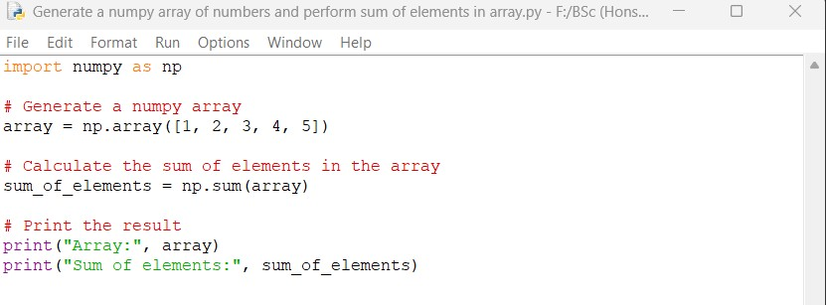

**Output obtained in execution:**

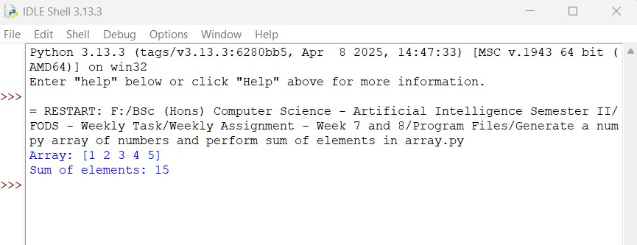

**4**

25024649

Python Program File: “Generate a numpy array of numbers and perform sum of elements in array.py.”

**Explanation of code:**

Importing Numpy:

This line imports the Numpy library and allows you to use it with the alias ‘np’. NumPy is a powerful library for numerical computations in python.

Creating a Numpy Array:

Here, a NumPy array named ‘array’ is created using the ‘np.array()’ function. The array contains the integers 1, 2, 3, 4, and 5.

Calculating the Sum of Elements:

sum_of_elements = np.sum(array)

The ‘np.sum()’ function is called with the ‘array’ as an argument. This function calculates the sum of all the elements in the array. In this case, it adds 1 + 2 + 3 + 4 + 5, resulting in 15 as sum.

Printing the Results:

The ‘print()’ function is used to display the contents of the array and the sum is calculated. The first print statement outputs the array, and the second print statement outputs the sum of its elements.

Conclusion of the Program:

The given python program is an example of how to create a NumPy array and perform basic operation (sum) on its elements. The output shows the original array and the result of the sum. This shows an example of using NumPy for numerical computations.

**5**

25024649

b) Average of elements in array

**Answer:**

The given python program below generates a Numpy array of numbers and calculates the average of its elements.

**Following code for input:**

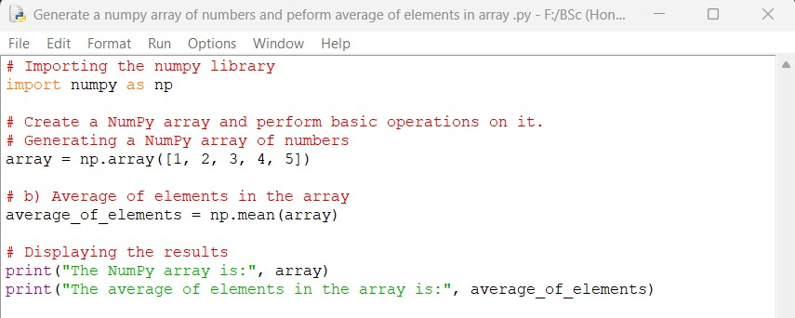

**Output obtained in execution:**

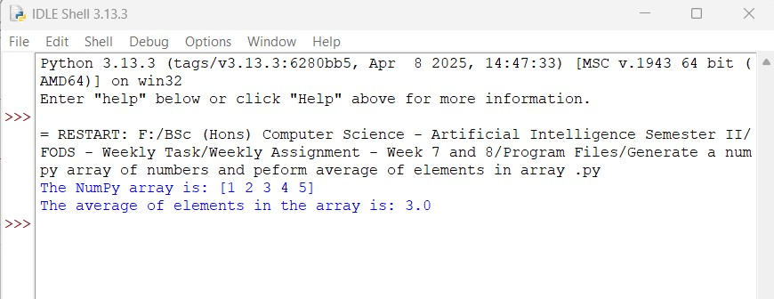

**6**

25024649

Python Program File: “Generate a numpy array of numbers and perform average of elements in array.py.”

**Explanation of code:**

Importing Numpy:

The program begins by importing the Numpy library, which is essential for creating and manipulating arrays.

Creating a NumPy Array:

The ‘np.array()’ function is used to create a NumPy array containing the numbers 1 through 5.

Calculating the Average:

The ‘np.mean()’ function calculates the average (mean) of all elements in the array.

Displaying the Results:

The program prints the original array and the average of all elements in array.

Conclusion of the Program:

The given python program is an example of how to create a NumPy array and perform a basic operation – calculating the average of its elements. The ‘np.mean()’ function provides a way to calculate the average of all elements in array, showcasing NumPy’s capabilities for efficient numerical calculations.

**7**

25024649

c) Identify maximum and minimum values in the array

**Answer:**

The given python program below identifies the maximum and minimum values in a NumPy array. It generates a NumPy array of numbers and finds both the maximum and minimum values.

**Following code for input:**

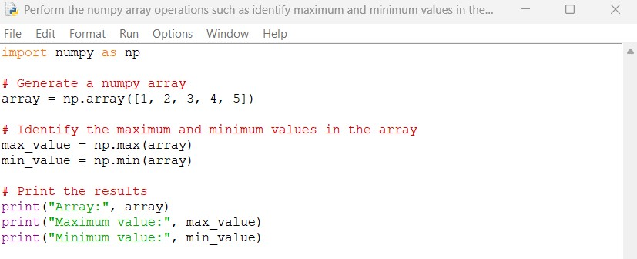

**Output obtained in execution:**

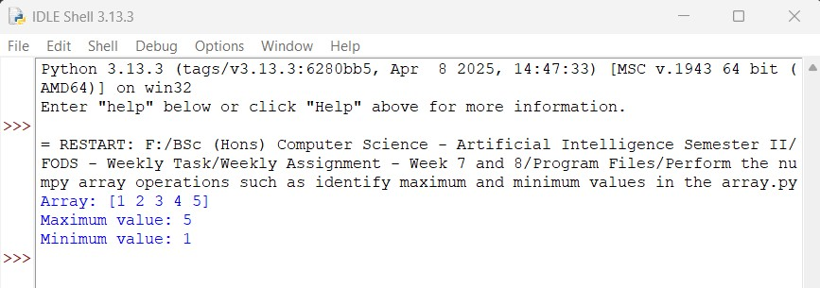

**8**

25024649

Python Program File: “Perform the numpy array operations such as identify maximum and minimum values in the array.py.”

**Explanation of code:**

**Import NumPy:**

The program starts by importing the NumPy library.

Create an Array:

A NumPy array is created with the numbers 1 through 5.

Find Maximum Value:

The ‘np.max()’ function is used to find the maximum value in the given array.

Find the Minimum Value:

The ‘np.min()’ function is used to find the minimum value in the array.

Output of the Program:

Finally, the array, its maximum value, and minimum value are printed to the console.

Conclusion of the Program:

The given program demonstrates how to create a NumPy array and perform operations to find the maximum and minimum values within that given array. The output shows the original array along with the resulted maximum and minimum values.

**9**

25024649

2. Write a program to input an array of numbers from the user (at least 10 elements in list), sort them and perform slicing operations to get elements between indexes such as 2-5, 5-8, 2-9.

**Answer:**

The given python program below takes a list of numbers from the user (minimum 10 elements), sort them, and performs slicing operations.

**Following code for input:**

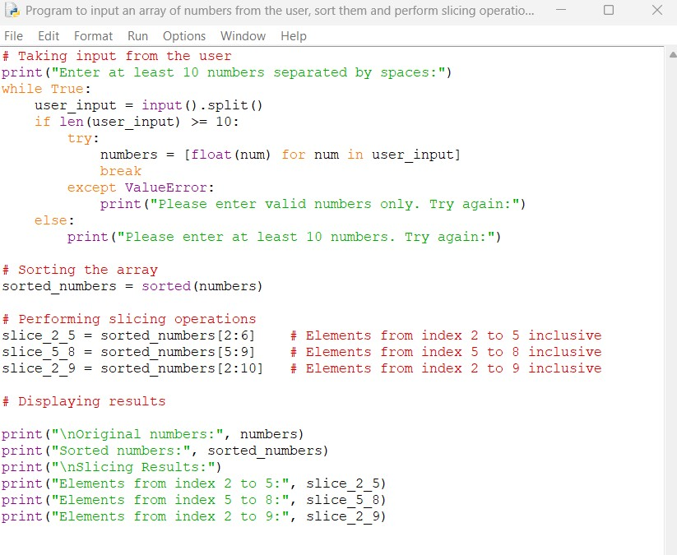

**10**

25024649

**Output obtained in execution:**

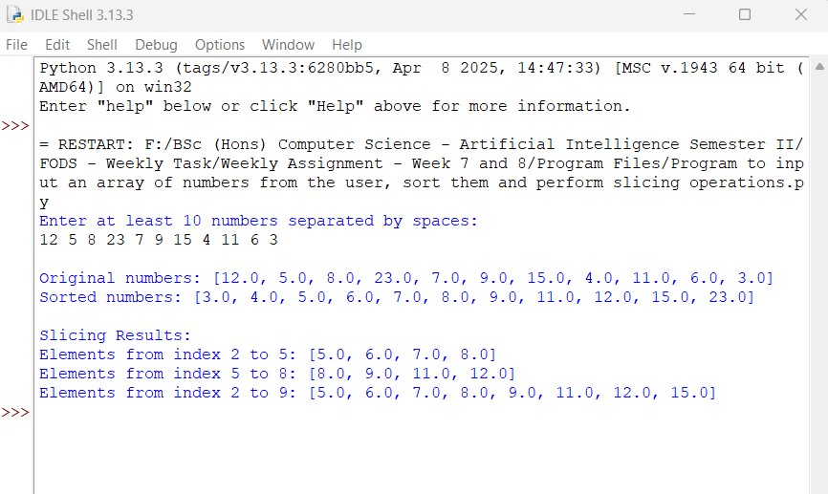

Python Program File: “Program to input an array numbers from the user, sort them and perform slicing operations.py.”

**Explanation of code:**

Input Handling:

The program prompts the user to enter at least 10 numbers separated by spaces. It validates the input for the user to ensure at least 10 numbers are entered. It can convert the input strings to float numbers.

Sorting:

The entered numbers are sorted in ascending order using the built-in function ‘sorted()’.

**11**

25024649

Slicing:

Slicing uses ‘start:stop’ notation where ‘start’ is inclusive and ‘stop’ is exclusive. For index 2-5, we ‘[2:6]’ to get elements at positions 2, 3, 4, 5. Similarly we use slicing for other ranges.

Output of the Program:

It shows the original input, sorted list, and the three requested slices.

Conclusion of the Program:

Th given python program is an example of data handling, showcasing concepts such as input validation, sorting algorithms, and data manipulation through slicing.

3. Create an array of random integer numbers as a numpy array, sort them and perform operations such as reshaping of the array into matrix of feasible dimensions. (e.g., if we have an array of 1 * 10, then we can reshape it into 2 * 5 or 5 * 2 matrix.) [Hint: Use the array of reshape (row * column) ].

**Answer:**

The given python program below creates a random array, sorts it, and performs reshaping of array operation.

**12**

25024649

**Following code for input:**

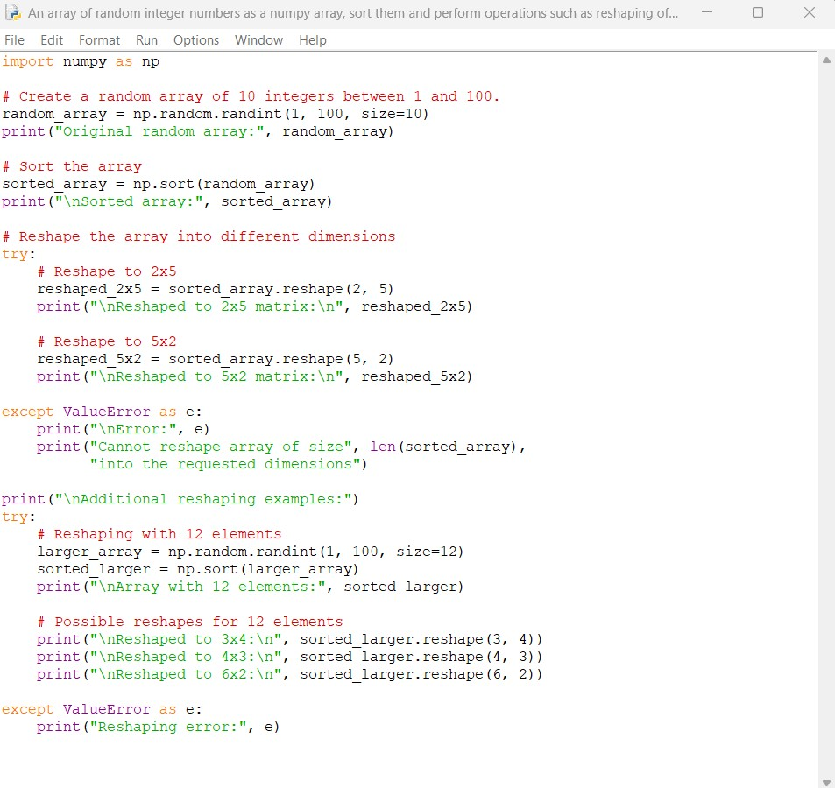

**13**

25024649

**Output obtained in execution:**

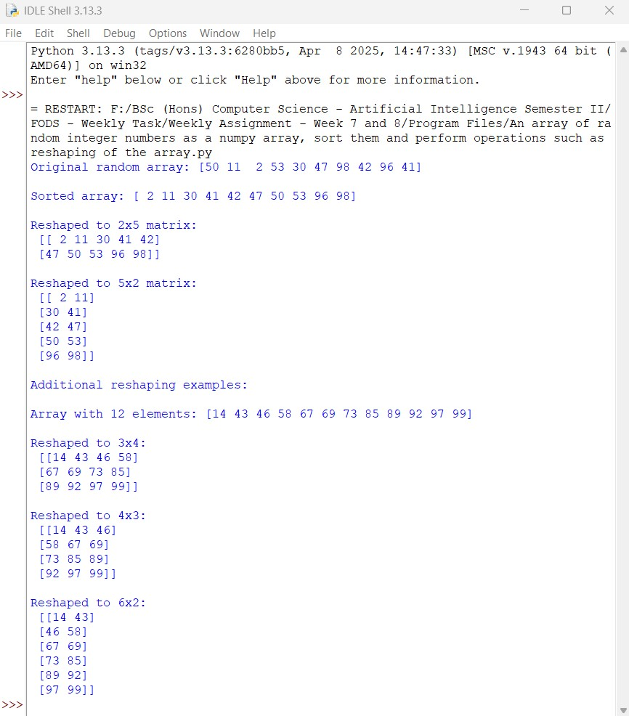

Python Program File: “An array of random integer number as a numpy array, sort them and perform operations such as reshaping of the array.py.”

**14**

25024649

**Explanation of code:**

Random Array Generation:

The ‘np.random.randint(1, 100, size=10)’ creates an array of 10 random integers between 1 and 100. The size of the parameter determines how many elements are generated in the array.

Sorting:

‘np.sort()’ sorts the array in ascending order which creates a new sorted array without modifying the original one.

Reshaping:

The method ‘reshape(2, 5)’ converts the 1D array into a 2 5 matrix, another method, ‘reshape(5, 2)’ converts it into a 5 2 matrix, and the product of dimensions must equal the original array size (2 5 = 10, 2 5 = 10).

Error Handling:

The try-except block catches cases where the reshaping isn’t possible in the program. For example, if user could not reshape a 10-element array into a 3 3 matrix ( 9 elements).

Additional Reshaping with Elements:

The program demonstrates reshaping with 12 elements and shows the possible reshapes like 2 5, 2 5, and 2 5 matrix.

Conclusion of the Program:

The given python program is an example of NumPy’s capabilities for array and data manipulation. It showcases aspects such as random array generation, sorting, reshaping arrays, and error handling.

**15**

25024649

4. Write a program to input 2 matrices of certain dimensions and perform the matrix operations such as additions, subtraction, multiplication using numpy. Validation of matrix size should be done before the operations are performed. Mismatch of size for operations should raise the exception.

**Answer:**

The given python program below allows the user to input two matrices, validates their sizes, and performs matrix operations such as addition, subtraction, and multiplication using NumPy.

**Following code for input:**

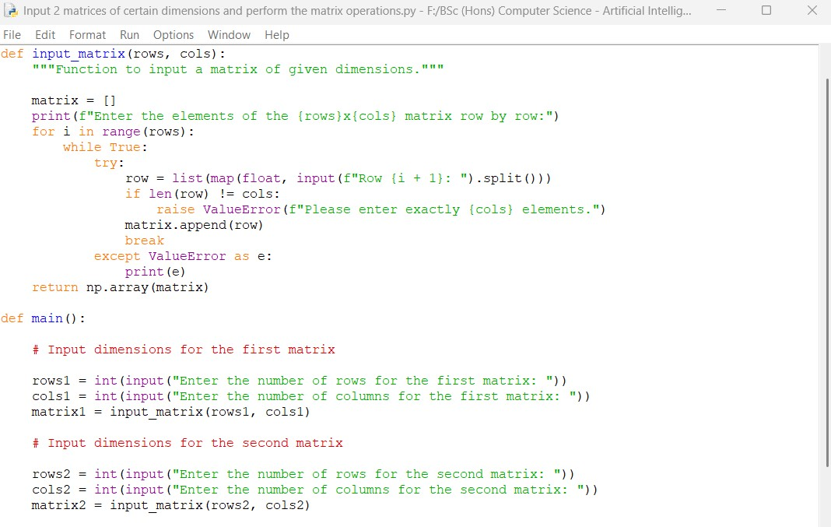

**16**

25024649

**Continue:**

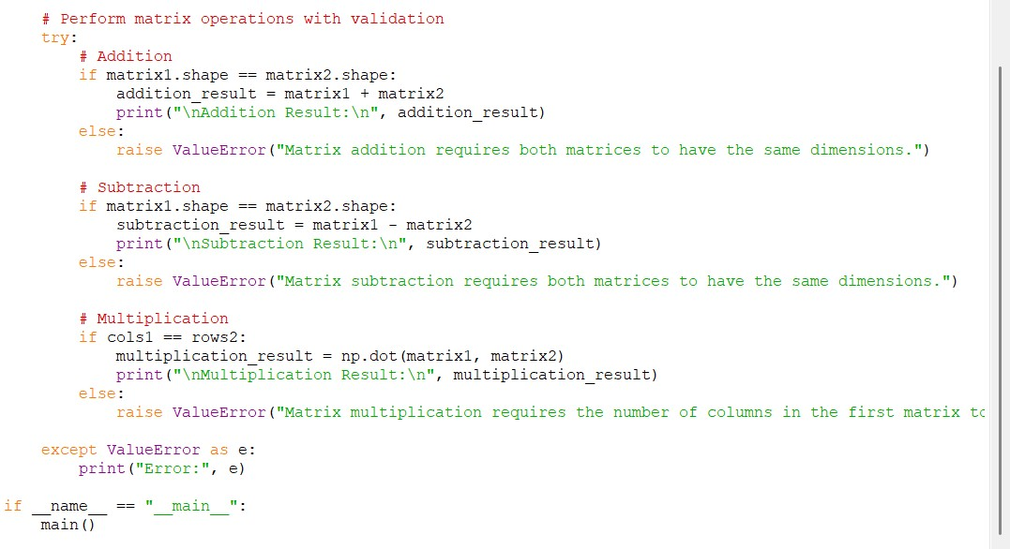

**17**

25024649

**Output obtained in execution:**

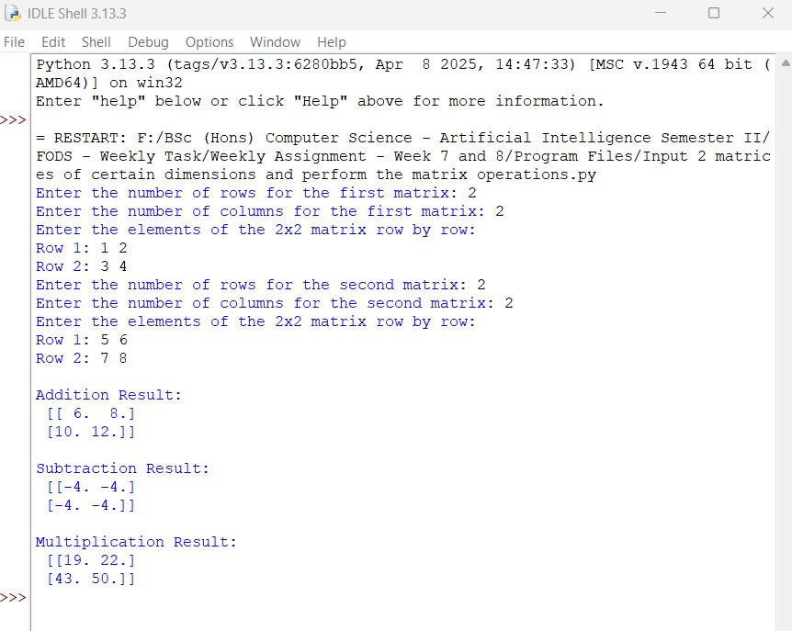

Python Program File: “Input 2 matrices of certain dimensions and perform the matrix operations.py.”

**Explanation of code:**

Input Function:

The ‘input_matrix’ function prompts the user to enter the elements of a matrix row by row. It validates that the correct number of elements is entered for each row.

**18**

25024649

Main Function:

The program starts by asking the dimensions of the first and second matrices from the user. It then calls the ‘input_matrix’ function to create the matrices.

Matrix Operations:

For addition, it checks if the shapes of the two matrices are the same before performing addition. For subtraction, it checks for shape compatibility. For multiplication, it checks if the number of columns in the first matrix matches the number of rows in the second matrix before performing the multiplication using ‘np.dot()’.

Error Handling:

The program could raise exceptions with the messages if the matrices are not compatible for the requested operations.

Conclusion of the Program:

The given python program is an example of how to handle matrix operations in python using NumPy. It shows user input validation, error handling, and the use of dimensions in mathematical operations such addition, subtraction, and multiplication.

5. Write a program to read the csv file “weight_height.csv” using Pandas. Plot the data as a scatterplot (weight vs height, age vs weight, height vs age, gender vs height, gender vs weight) using Matplotlib library.

**19**

25024649

**Answer:**

The given python program below reads the CSV file “weight_height.csv” and plots the specified scatterplots using Pandas and Matplotlib. The program uses necessary libraries installed (‘pandas’ and ‘matplotlib’).

Read CSV file weight_height.csv:

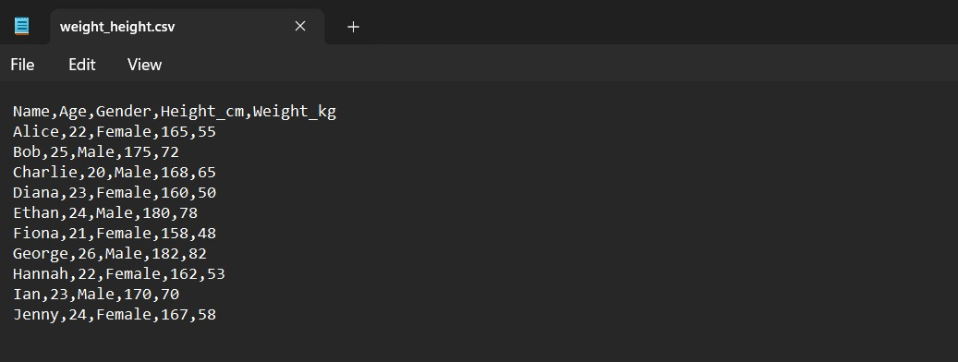

**20**

25024649

**Following code for input:**

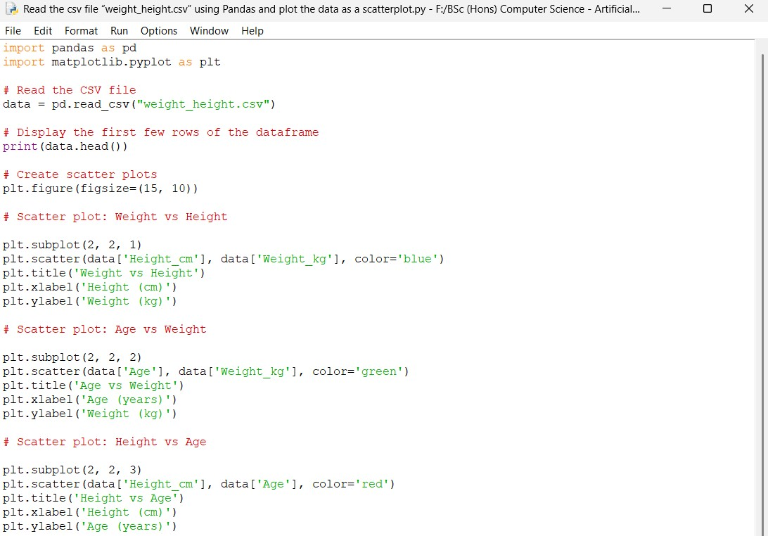

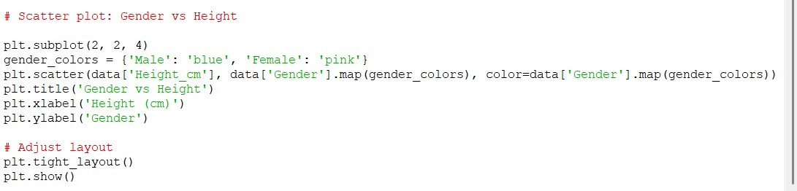

**21**

25024649

**Output obtained in execution:**

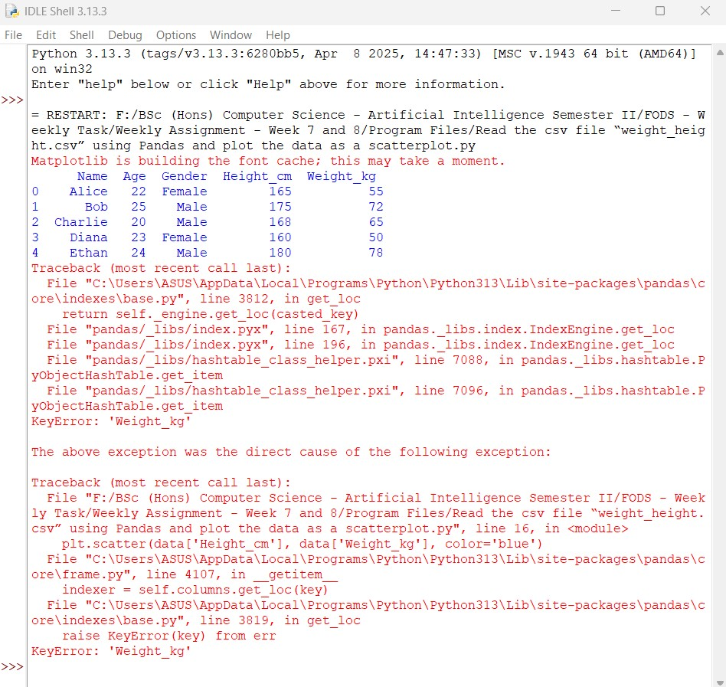

Python Program File: “Read the csv file “weight_height.csv” using Pandas and plot the data as a scatterplot.py.”

**22**

25024649

**Explanation of code:**

Import Libraries:

The program imports the necessary libraries, ‘pandas’ for data manipulation and ‘matplotlib.pyplot’ for plotting.

Read CSV File:

The program reads the CSV file “weight_height.csv” into a Pandas DataFrame using ‘pd.read_csv()’.

Display the Data:

It prints the first few rowsof the DataFrame to verify that the data has been loaded correctly.

Create Scatter Plots:

The program creates a figure with a specified size using ‘plt.figure()’ and creates four scatter plots in 2 2 grids. There is weight vs height, where the plots height on the x – axis and weight on the y – axis, age vs weight, where the plots age on the x – axis and age on the y – axis, height vs age, where the plots height on the x -axis and age on the y – axis, and gender vs height, where plots height on the x-axis and uses color to represent gender.

Adjust Layout:

The ‘plt.tight_layout()’ function is called to adjust the spacing between subplots for better visibility.

**23**

25024649

Show plots:

Finally, ‘plt.show()’ is called to display the plots.

Output of the Program:

After you run the program, the window displaying scatter plots based on the data from the CSV file is visible. Each plot is shown to have a relationship between the specified variables.

Conclusion of the Program:

The given python program is an example to execute a script to read a CSV file and plot a scatterplot using libraries such as Pandas and Matplotlib.

6. Read the data from csv file “weight_height.csv” in a data frame using Pandas. Add 2 additional columns (BMI and Risk) in the existing DataFrame. Add the data according to the calculations given below.

BMI = Weight / Height

Risk values vary according to the conditions given below:

BMI less than 18.5 : Nutrient deficient

BMI between 18.5 and 24.9: lower risk

BMI between 25 and 29.9: Heart disease risk

BMI between 30 and 34.9: Higher risk of diabetes, heart disease

BMI 40 or higher: Serious health condition risk

**25**

25024649

**Answer:**

The given python program below to read the data from the CSV file “weight_height.csv” and add the BMI and Risk columns to the Dataframe using Pandas.

**Following code for input:**

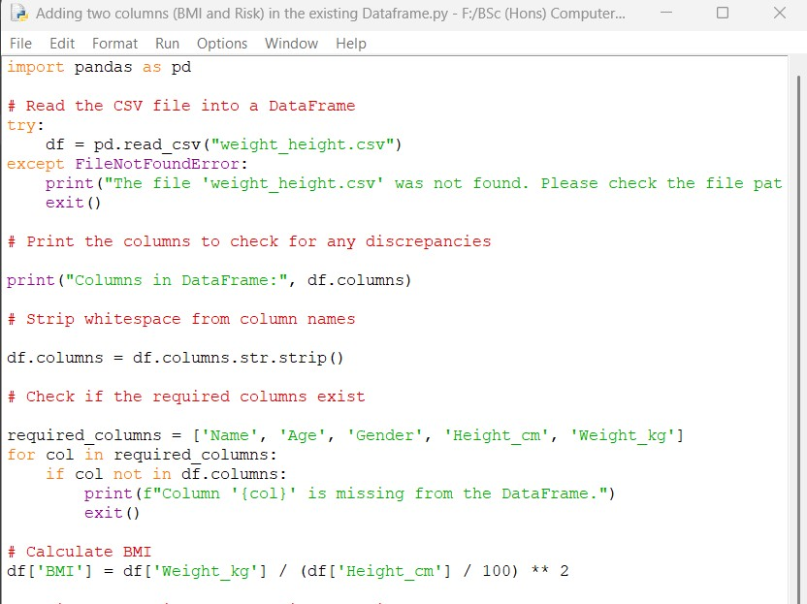

**25**

25024649

**Continue:**

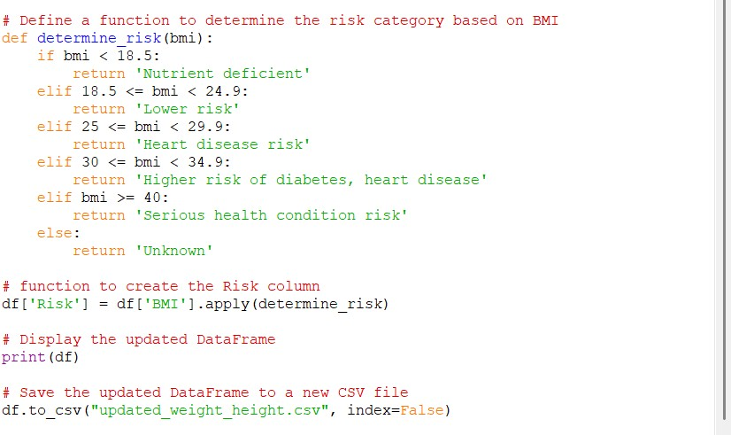

**Output obtained in execution:**

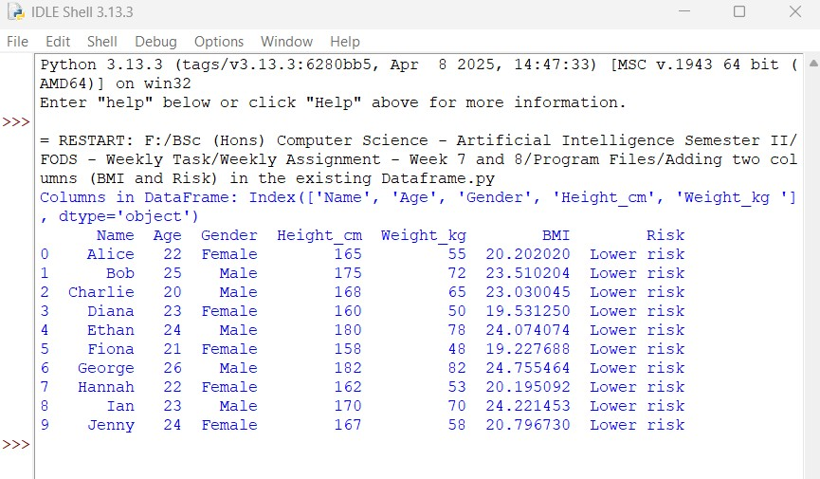

**26**

25024649

**Original CSV File “weight_height.csv”:**



**Updated CSV File “updated_weight_height.csv”:**

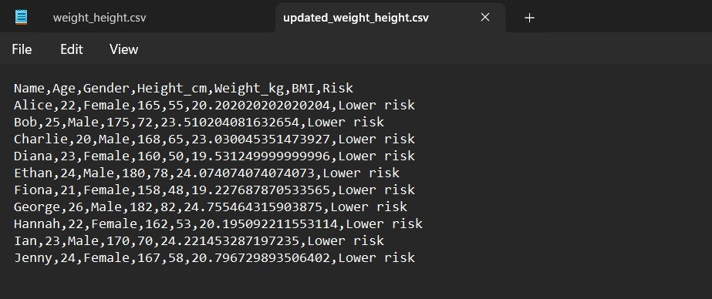

Python Program File: “Adding two columns (BMI and Risk) in the existing Dataframe.py.”

**27**

25024649

**Explanation of code:**

Importing Pandas:

The code begins by importing the Pandas library, which is used for data manipulation and analysis.

Reading the CSV File:

The ‘pd.read_csv’ function reads the weight_height.csv” file into a DataFrame named ‘df’.

Error Handling:

A ‘try-except’ block is used to catch a ‘FileNotFoundError’. If the file is not found, an error message is printed, and the program exits.

Printing Column Names:

The current column names of the DataFrame are printed to the console. This helps in identifying any inconsistency in the column names section.

Stripping Whitespace:

The ‘str.strip()’ method is applied to the column names to remove any leading or trailing whitespace, which can cause issues when accessing the columns.

Required Columns Check:

A list of required column names is defined. The code iterates through the list to check if each column exits in the Dataframe.

Error Handling for Missing Columns:

An error message is printed and programs exits if any required column is missing.

**28**

25024649

BMI Calculation:

The Body Mass Index (BMI) is calculated using the formula BMI = . The height is converted from centimeters to meters by dividing by 100. The result is stored in a new column named ‘BMI’.

Risk Determination Function:

A function ‘determine_risk’ is defined to categorize the health risk based on the BMI value. The use of conditional statements to return the appropriate risk category.

Creating the Risk Column:

The ‘apply’ method is used to apply the ‘determine_risk’ function to each value in the ‘BMI’ column. The results are stored in a new resulting column named ‘Risk’.

Displaying the Dataframe:

The updated DataFrame, which now includes the columns ‘BMI’ and ‘Risk’, which is printed to the console.

Saving the DataFrame:

The method ‘to_csv’ is used to save the updated DataFrame to a new CSV file named “updated_weight_height.csv”. The ‘index=False’ argument prevents Pandas from writing the row indices to the CSV file, resulting in a output.

Output of the Program:

The program first prints the column names of the DataFrame, which helps the user to verify that the data has been read correctly. After the calculating the BMI and the risk determination categories, the program prints the updated DataFrame. The program saves the updated DataFrame to a new CSV file named “updated_weight_height.csv”. The file will contain all the original data along with the newly calculated BMI and Risk columns.

**29**

25024649

Conclusion of the Program:

The given python program reads a CSV file containing individuals’ weight and height data, it calculates the Body Mass Index (BMI), and their category wise health risk based on the BMI values.

**30**